**Money Management Portal**

**Retirement (Heading)**

**Retirement Planning Tools (Big Blue Button)**

* Retirement Calculator

1.

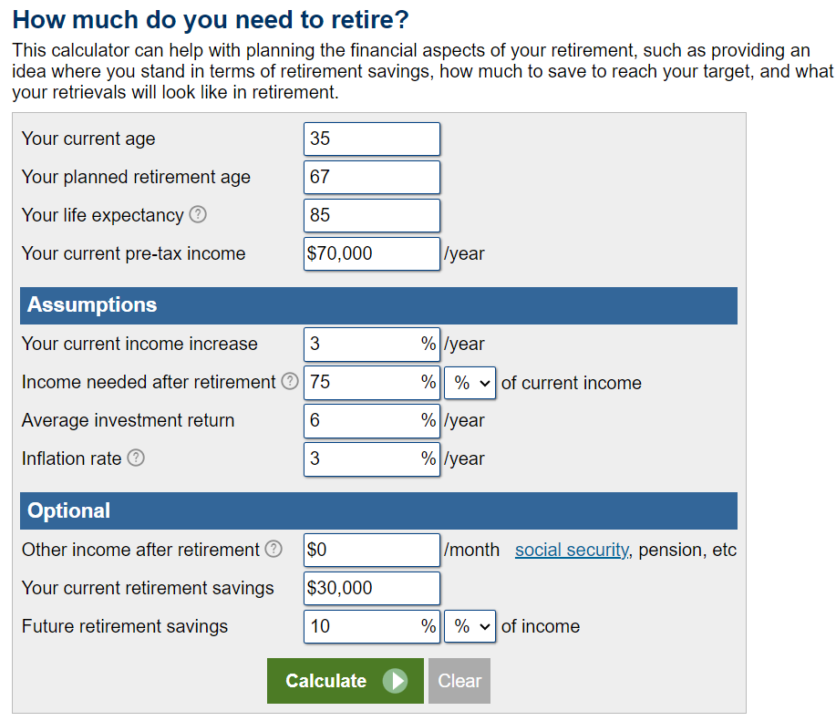

2.

3.

4.

* **Saving Goals**

(This chart will come under this button(section))

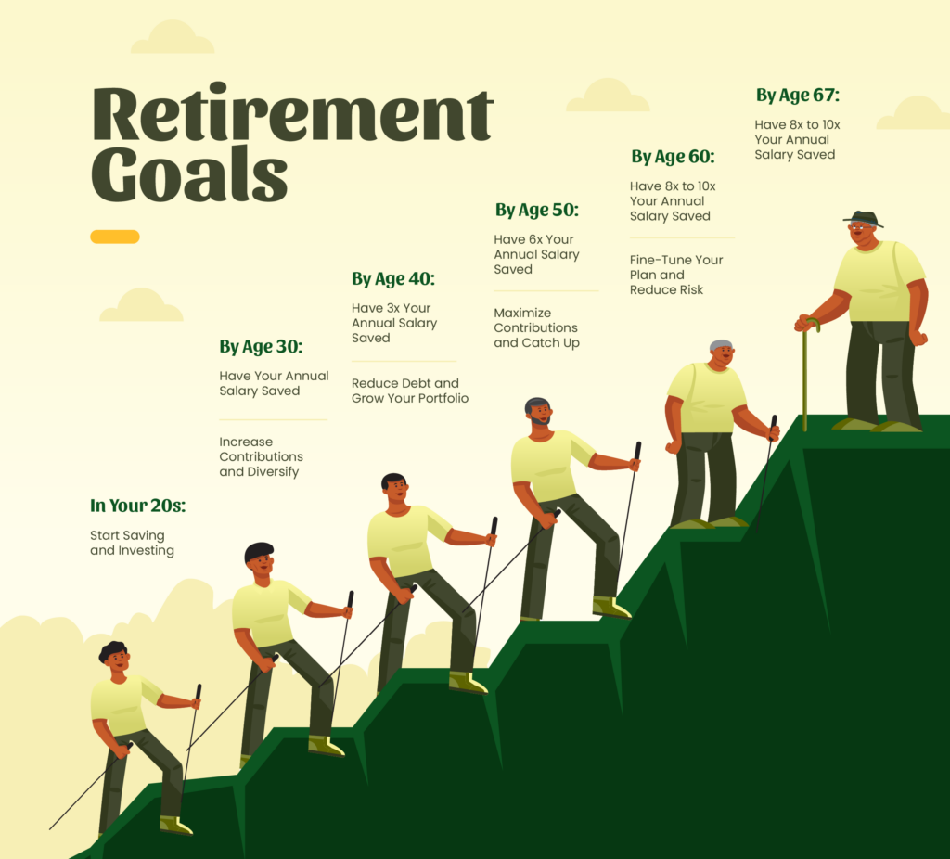

(Information to be extracted from this picture regarding Retirement Saving Goals)

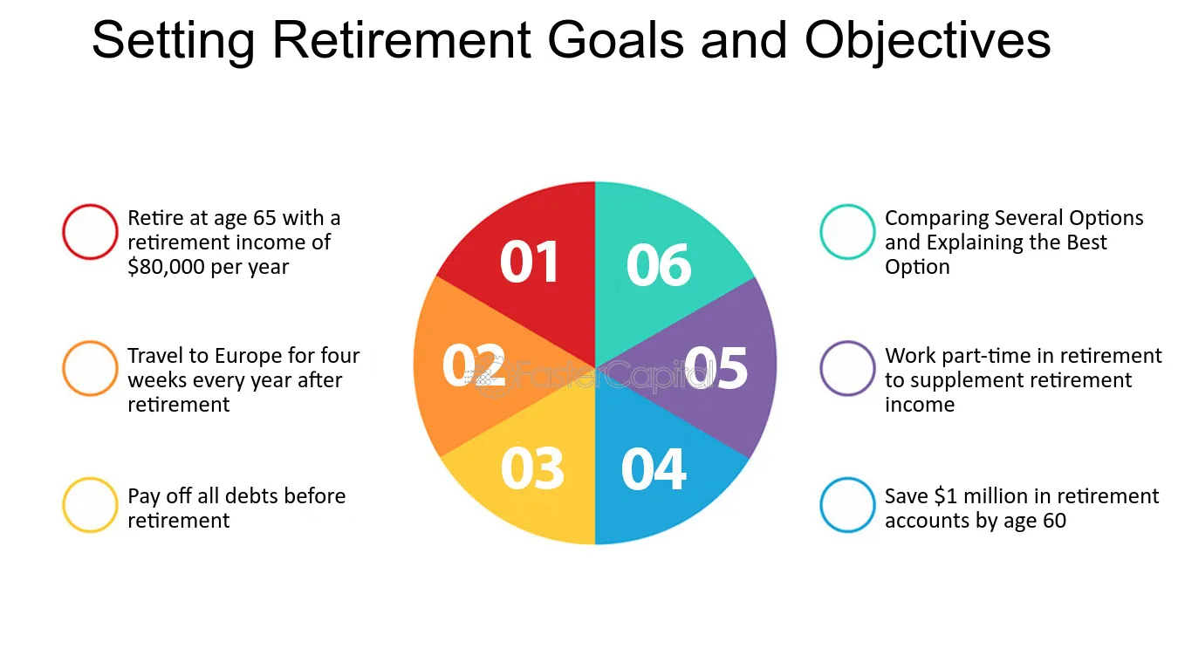

(Under this chart this line will appear):

For more Information about Retirement Saving Goals,

Contact: **Rich**

**Investment Options (Big Blue Button)**

* Risk Assessment Management

**(Include this under this specific screen button):**

**1. Portfolio Risk Analysis**

* **What to Look For**: A detailed report showing the overall risk of your portfolio, including metrics like volatility (standard deviation) and market correlation (beta).
* **Why It's Important**: This provides insight into how much your portfolio value might fluctuate and how it moves in relation to the overall market, helping you gauge the stability of your investments.

**2. Diversification Analysis**

* **What to Look For**: Reports on how well-diversified your portfolio is across different asset classes, sectors, and geographic regions.
* **Why It's Important**: Diversification reduces risk by spreading investments across various areas, minimizing the impact of any single investment's poor performance.

**3. Liquidity Risk Assessment**

* **What to Look For**: Analysis of how easily you can buy or sell investments without significantly affecting their prices.
* **Why It's Important**: Liquidity is crucial for ensuring you can access your funds when needed, particularly important for retirees who may need to draw on their investments for living expenses.

**4. Tax Implications and Optimization**

* **What to Look For**: Information on the tax implications of your investment choices and strategies for minimizing tax liability.
* **Why It's Important**: Understanding and optimizing your tax situation can help you preserve more of your retirement savings, enhancing your financial stability.
* **Retirement Accounts**

**(FUNTIONALITY):**

• **Account Types Management**: Enable users to add, view, and manage various retirement accounts such as 401(k), IRA, Roth IRA.

• **Balance and Transaction Tracking**: Display current account balances and provide a transaction history including contributions, withdrawals, and fees.

• **Investment Management**: Allow users to allocate funds among different investment options within their retirement accounts and provide tools for portfolio rebalancing.

• **Performance Analysis**: Show the performance of retirement accounts over time with charts/graphs, including gains/losses and comparisons against benchmarks.

• **Tax Considerations**: Provide tax-related information such as contribution limits, tax deductions (for traditional IRAs), and tax-free growth (for Roth IRAs).

**Retirement Income Planning (Big Blue Button)**

* **Annuity Calculators**

* **Social Security Estimator**

**(Include these 2 more options under Marital Status:**

**Full Earnings History**

**Anticipated Retirement Age**

**)**

**Tax Planning (Big Blue Button)**

* **Roth Conversion Calculator**

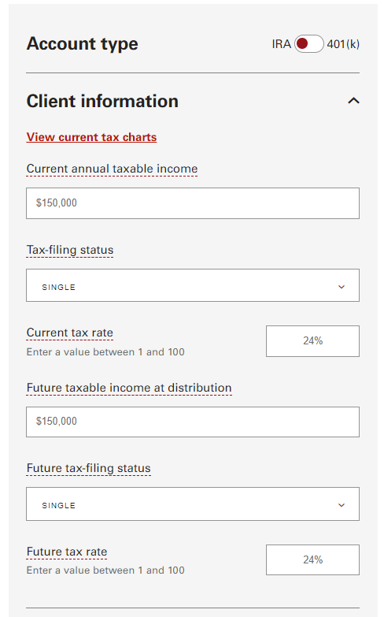

**(On changing these information In the above pictures, the below graph and text will change wisely):**

* **Tax-efficient Withdrawal Strategies**

**Tax-Efficient Withdrawal Strategies for Retirement**

Planning your retirement withdrawals strategically can help minimize tax liabilities and maximize your retirement income. Here are key considerations and tools to help you navigate tax-efficient withdrawal strategies:

**Understanding Retirement Accounts and Taxation**

* **Know Your Accounts**: Understand how different retirement accounts (e.g., traditional IRA, Roth IRA, 401(k)) are taxed during contributions, growth, and withdrawals.
* **Tax Bracket Basics**: Familiarize yourself with tax brackets and how your withdrawals can impact your taxable income in retirement.

**Strategies for Tax-efficient Withdrawals**

* **Sequential Withdrawals**: Consider withdrawing from taxable accounts first to allow tax-deferred accounts (e.g., traditional IRAs, 401(k)s) to continue growing tax-deferred.

**Asset Location Optimization**

* **Asset Allocation**: Optimize the placement of assets between taxable, tax-deferred, and tax-free accounts to minimize overall taxes. Consider which investments are best held in each account type for tax efficiency.

**Managing Required Minimum Distributions (RMDs)**

* **Plan for RMDs**: Understand the rules and implications of Required Minimum Distributions (RMDs) from tax-deferred retirement accounts starting at age 72 (or 70½ for those born before July 1, 1949).

**Professional Guidance**

* **Consultation with Advisors**: Consider consulting with a tax advisor or financial planner for personalized recommendations tailored to your specific financial situation and retirement goals.

**Resources and Tools**

* **Our Roth IRA Conversion Calculator:** Access retirement income planners and our very own Roth IRA Conversion Calculator Roth IRA conversion calculator to simulate different withdrawal strategies and tax scenarios.

**(Insert a Graph after this above text):**

**Budgeting Tools (Big Blue Button)**

* **Expense Tracking**

**Expense Tracking**

Tracking your expenses is crucial for understanding your financial habits and achieving your financial goals. Here’s how to effectively track and manage your expenses:

**Importance of Expense Tracking**

* **Financial Awareness**: Gain insights into where your money goes each month to make informed financial decisions.
* **Budgeting**: Create and maintain a realistic budget based on your spending patterns.

**Categorizing Expenses**

* **Fixed vs. Variable Expenses**: Differentiate between essential fixed expenses (e.g., rent, utilities) and discretionary variable expenses (e.g., dining out, entertainment).
* **Monthly vs. Irregular Expenses**: Track both regular monthly expenses and occasional or irregular expenses (e.g., car maintenance, vacations).

**Setting Financial Goals**

* **Goal Alignment**: Align your expense tracking with financial goals such as saving for retirement, paying off debt, or building an emergency fund.
* **Tracking Progress**: Monitor your progress towards achieving financial goals by reviewing your expense patterns and adjusting spending as needed.

**Benefits of Regular Tracking**

* **Financial Discipline**: Develop financial discipline by maintaining regular expense tracking habits.
* **Expense Reduction**: Find opportunities to reduce unnecessary expenses and increase savings.

**(This will appear after the above headings and body):**

For more Information about Retirement Saving Goals,

Contact: **Rich**

* Retirement Budget Planner

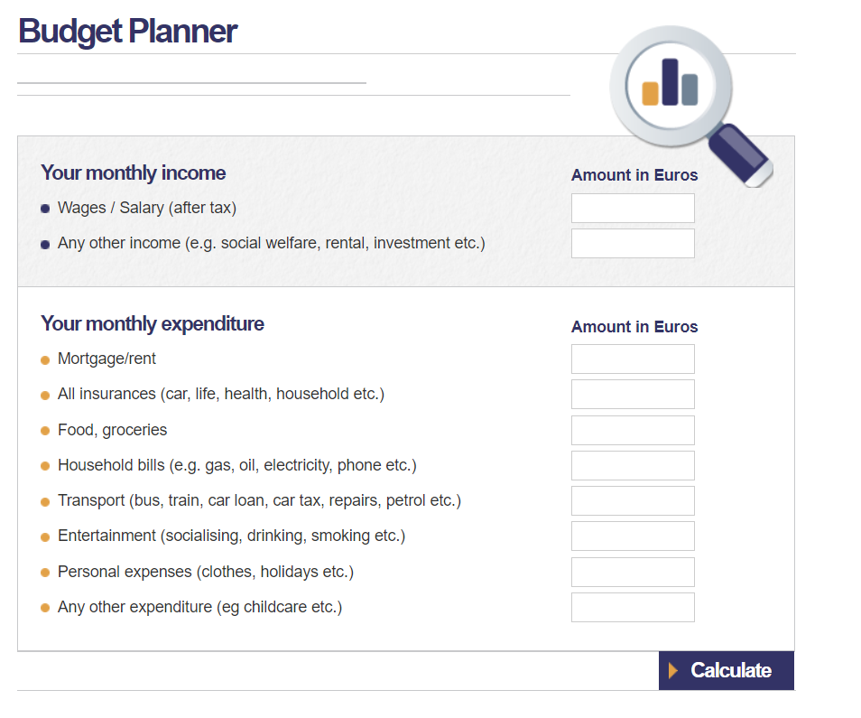

(This is just an example, keep following the theme for layout purposes)

**Insurance (Heading)**

**Insurance Policy Management (Big Blue Button)**

* **Policies**

- Provide with a descriptive view of Policies (provided by the site and site owner)

They should include and cover a wide variety of:

Policy Type (e.g., health, life, auto, home), policy number, provider, and coverage amount.

- Allow sorting and filtering of policies by type, provider, and other criteria.

**Premium Tracking and Payments (Big Blue Button)**

* **Premium Summary**

**(Display a summary of premium amounts for each policy, with a breakdown of monthly, quarterly, or annual payments).**

* **Payment Reminders**

• Provide reminders for upcoming premium payments to ensure users do not miss payment deadlines.

• Enable users to set up notifications or alerts for premium due dates.

**(THIS ACTUALLY POINTS OUT TO THE NOTIFICATIONS AB WHERE THE REMINDERS (THAT ARE ACTUALLY SET) WILL BE SHOWN TO THE USER)**

**EXAMPLE:**

**REMINDER:**

**Insurance Needs Assessment (Big Blue Button)**

* **Coverage Analysis**

**Life Insurance Needs Calculator:**

